PROJECT PLANNING PHASE
Project Planning Template – Product Backlog, Sprint Planning, Stories & Story Points

Date | 03 October 2026
Team ID | SWTID-2026-7991
Project Name | Script-Controlled ACL – Restrict Record Access Based on Field  Value
Maximum Marks | 5 Marks

Product Backlog, Sprint Schedule, and Estimation (4 Marks)
The backlog follows the supplied planning template: Sprint, Functional Requirement (Epic), User Story Number, User Story/Task, Story Points, Priority and Team Members.

Sprint | Functional  Requirement (Epic) | User Story Number | User Story / Task | Story Points | Priority | Team Members
Sprint-1 | User C Role Setup | USN-1 | As an administrator, I can create the EEE test user so that the ACL workflow can  be tested. | 2 | High
Sprint-1 | User C Role Setup | USN-2 | As an administrator, I can create roles bb1, bb2, bb3 and bb4 so that permissions can be separated by  operation. | 3 | High
Sprint-1 | Institution Details Table | USN-3 | As an administrator, I can create the u_institution_details table with the  required fields. | 3 | High
Sprint-1 | Institution Details Table | USN-4 | As an administrator, I can create ECE, EEE and CSE records so that record-level access  can be tested. | 2 | High
Sprint-2 | READ ACL | USN-5 | As a security administrator, I can configure a READ ACL for u_institution_details with the EEE branch  condition. | 3 | High
Sprint-2 | READ ACL | USN-6 | As a security administrator, I can use an advanced script to allow administrators and bb1 users while  denying others. | 3 | High
Sprint-2 | READ ACL | USN-7 | As a tester, I can impersonate users and verify EEE-only visibility, no-role denial and administrator  access. | 3 | High
Sprint-3 | CREATE C WRITE ACL | USN-8 | As a security administrator, I can configure a CREATE  ACL requiring bb2. | 2 | Medium

Sprint-3 | CREATE C WRITE ACL | USN-9 | As a security administrator, I can configure a WRITE  ACL requiring bb3. | 2 | Medium
Sprint-3 | CREATE C WRITE ACL | USN-10 | As a tester, I can verify create and edit permissions after combining  bb1, bb2 and bb3. | 3 | High
Sprint-4 | DELETE C Final Validation | USN-11 | As a security administrator, I can configure a DELETE  ACL requiring bb4. | 2 | Medium
Sprint-4 | DELETE C Final Validation | USN-12 | As a tester, I can validate the complete permission set and confirm the documented  project outcome. | 3 | High

Sprint-wise Estimation
Sprint | Planned Story Points | Focus
Sprint-1 | 10 | Users, roles, table and test data
Sprint-2 | 9 | READ ACL and access verification
Sprint-3 | 7 | CREATE and WRITE ACLs with verification
Sprint-4 | 5 | DELETE ACL and end-to-end validation

Project Tracker, Velocity & Burndown Chart (4 Marks)
Sprint | Total Story Points | Duration | Sprint Start Date | Sprint End Date (Planned) | Story Points Completed  (Planned) | Sprint Release Date (Actual)
Sprint-1 | 10 | 6 Days | 01 Oct 2026 | 06 Oct 2026 | 10
Sprint-2 | 9 | 6 Days | 07 Oct 2026 | 12 Oct 2026 | 9
Sprint-3 | 7 | 6 Days | 13 Oct 2026 | 18 Oct 2026 | 7
Sprint-4 | 5 | 6 Days | 19 Oct 2026 | 24 Oct 2026 | 5
Velocity: Total planned story points = 31. Number of sprints = 4. Average planned velocity = 31/4 = 7.75 story points per sprint.
For comparison with the supplied planning-logic example, velocity is calculated from completed/planned story points divided by the number of sprints. The supplied example calculates 32 points across 2 sprints as 16 story points per sprint.

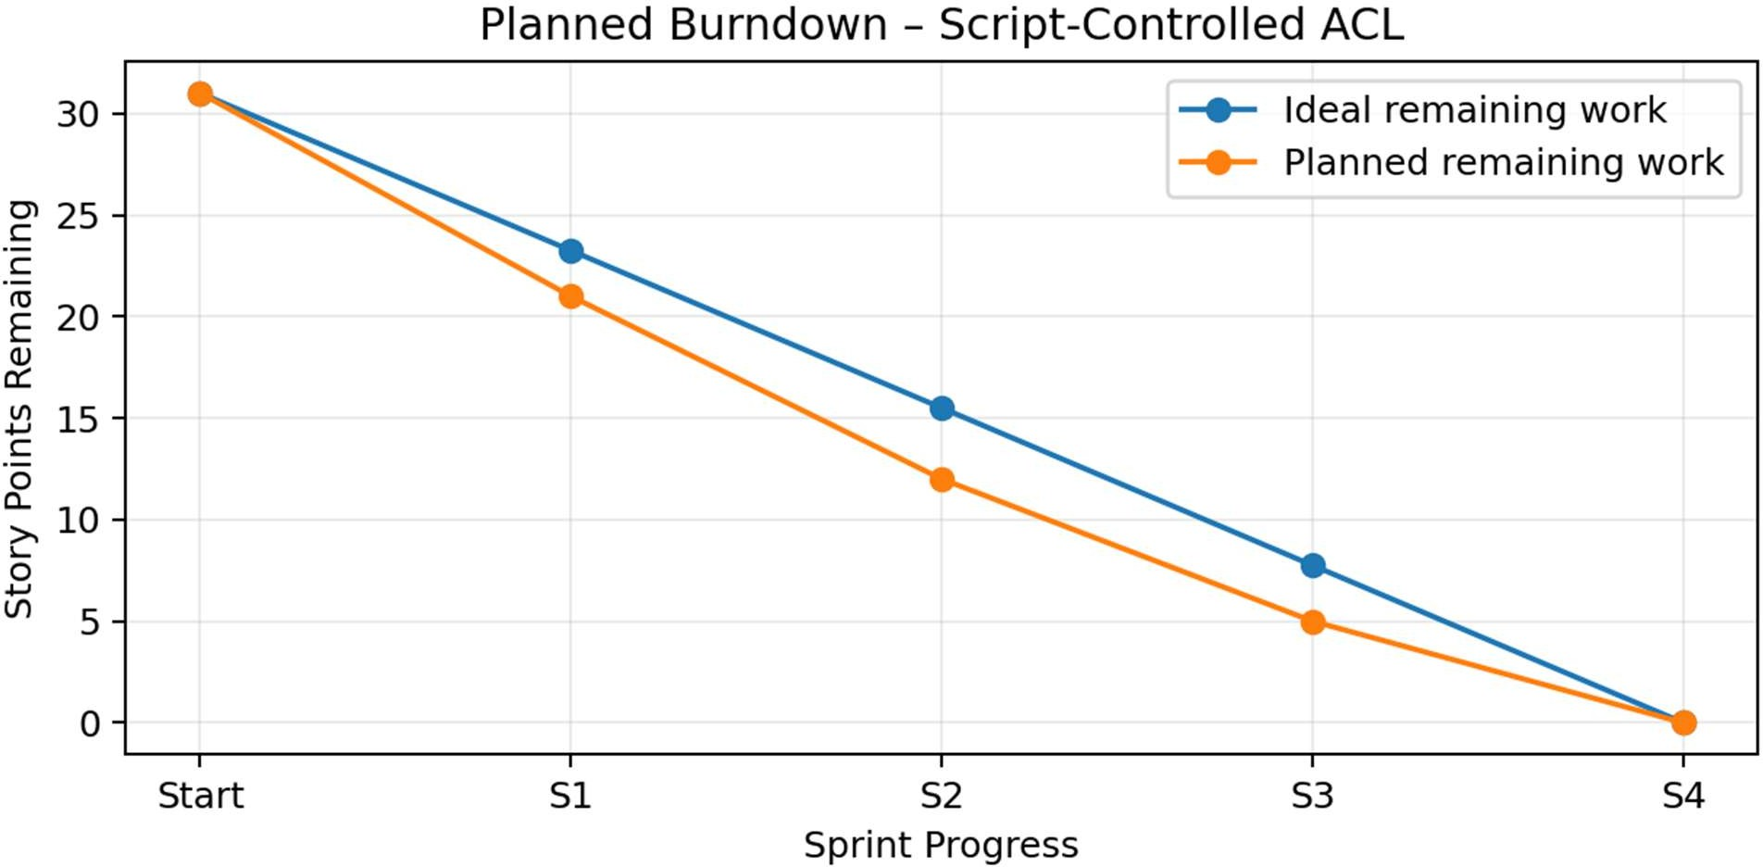

Burndown Interpretation
The burndown represents work remaining against sprint progress. The ideal line decreases evenly from the initial backlog to zero. The planned line drops according to the four sprint allocations: 10, 9, 7 and 5 story points.

Definition of Done
- The EEE test user and required roles are created.
- The Institution Details table and required fields are configured.
- ECE, EEE and CSE test records are available.
- READ ACL behavior is verified through impersonation.
- CREATE, WRITE and DELETE ACLs are configured and verified.
- The final combined role set is tested against the expected access behavior.
- Project documentation and sprint tracking are completed.

Planning Basis
This planning document uses the supplied Project Planning Template structure and the supplied Planning Logic document's concepts of sprint, epic, story, story point and velocity. The source planning logic defines story-point sizing using 1, 2, 3 and 5 as increasing effort levels and calculates velocity as total story points divided by the number of sprints.

